Molecular Biology Experiment Report
Dataset Overview
The dataset originates from a time series molecular biology experiment. Each sample represents a labeled experimental outcome (either "perfect" or "imperfect") and is characterized by a series of 100 time-point features (ranging from time 0 to time 99). These time points reflect molecular measurements across a fixed interval.
In its original form, the dataset structure places time points in the first column and individual sample measurements across the remaining columns. The labels are embedded within the sample column headers (e.g., "perfect.1", "imperfect.23"). To prepare the data for modeling, it was transposed such that each row corresponds to one sample and each column represents a single time point. Labels were extracted, cleaned, and encoded into numeric form.
Data Cleaning and Transformation
Several preprocessing steps were taken to ensure the dataset was machine learning-ready:
- String Removal and Conversion: Non-numeric entries such as "good", "early", and other string artifacts were identified and removed by coercing all entries to numeric using pd.to_numeric(errors='coerce'). This transformed non-numeric strings into NaN values.
- Handling Zeros as Missing Values: Based on domain-specific insights (i.e., time-series biological signal data), zero values were assumed to represent undetectable or missing signal rather than true biological zeros. These were therefore replaced with NaN.
- Dropping Fully Missing Features: Columns that contained only NaN values were removed entirely, as they contained no usable information.
- Imputation: Remaining missing values, including those originally represented as zero, were imputed using the mean of each column. This ensured a complete dataset for downstream modeling while preserving trends across time points.
- Low-Variance Feature Removal: Features with near-zero variance (threshold < 1e-6) were removed using VarianceThreshold. These features carried little to no discriminatory power.
- Scaling: Standardization was applied using StandardScaler to normalize feature values, centering them at zero mean with unit variance.
Exploratory Data Analysis (EDA)
EDA was conducted to further understand the structure and nuances of the dataset:
- Missing Value Heatmap: A heatmap was created to visualize where missing data was located across samples and time points. Missingness was not uniformly distributed and appeared more often at early and late time points.
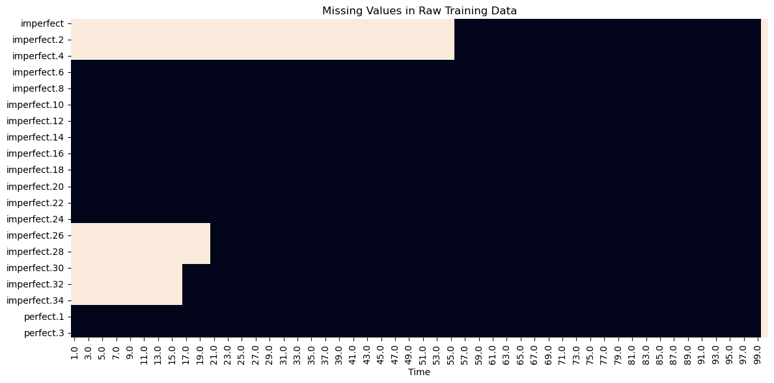
- Missing Value Bar Plot: A bar plot summarized the number of missing values per time point, confirming the non-uniform distribution observed in the heatmap.
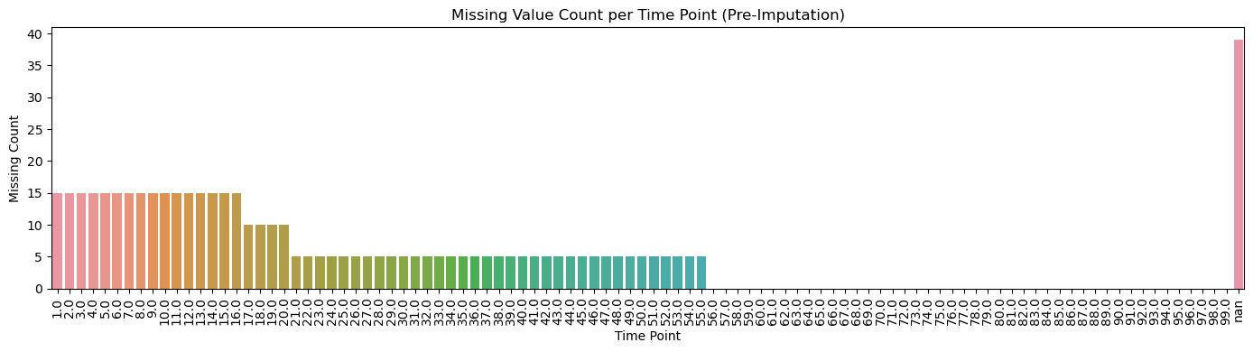
- Class Distribution: A count plot revealed that the dataset is significantly imbalanced, with a large majority of samples labeled "imperfect" and very few labeled "perfect".
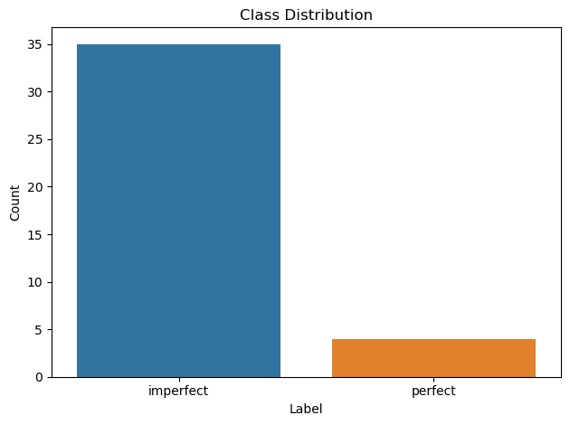
- Constant Columns: A check identified columns with constant values across all samples, which were excluded to reduce dimensionality.
- Mean Signal Curves: The average signal over time was plotted separately for each class. These curves showed visible differences in slope and intensity, suggesting that the temporal signal structure may hold predictive value.
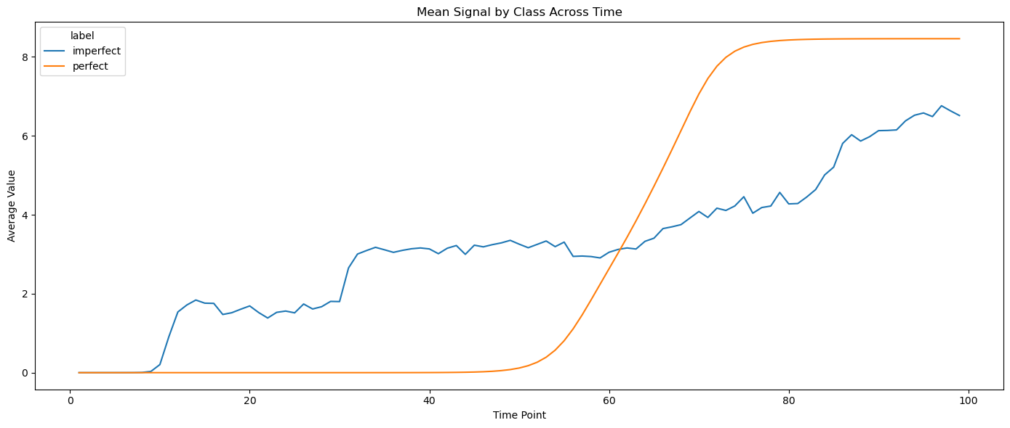
- Feature Correlation Heatmap: A correlation matrix heatmap revealed high autocorrelation between adjacent time points, which is consistent with expectations for biological time series data.
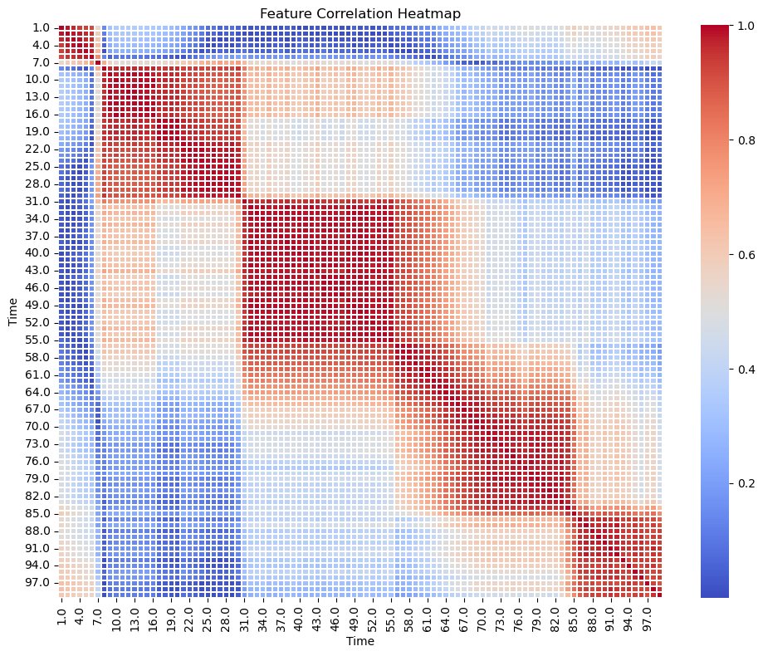
- Top Variance Features: A bar plot identified the top 10 most variable features, providing insight into the most informative time points.
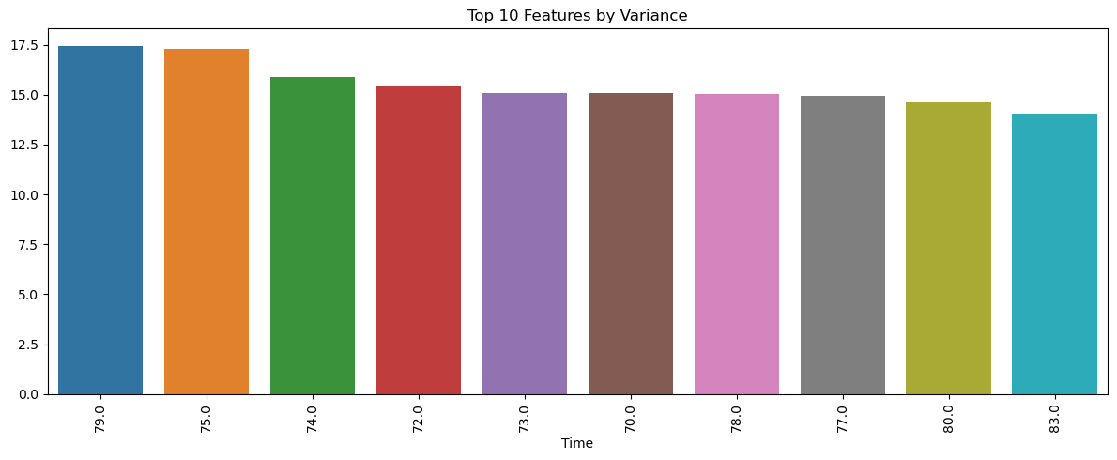
- Highly Correlated Feature Pairs: The top five most correlated feature pairs were identified, and scatterplots were generated for each. These visualizations confirmed strong linear associations between certain time points.
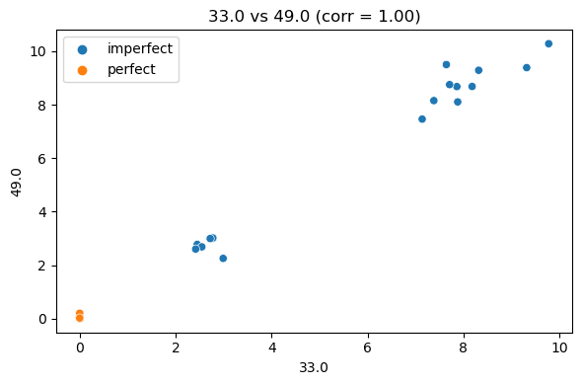 | 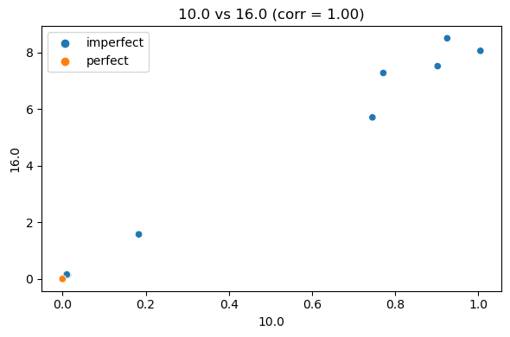
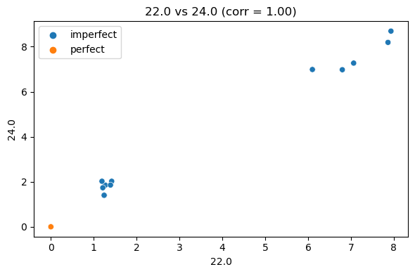 | 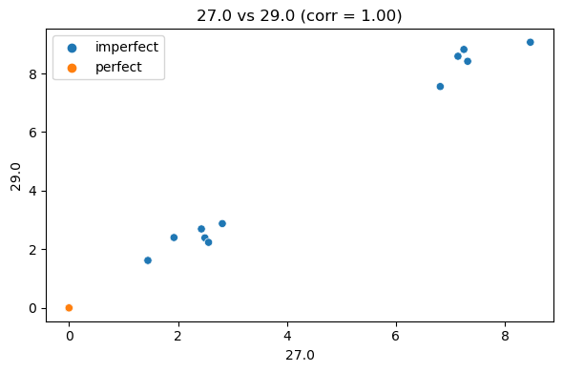
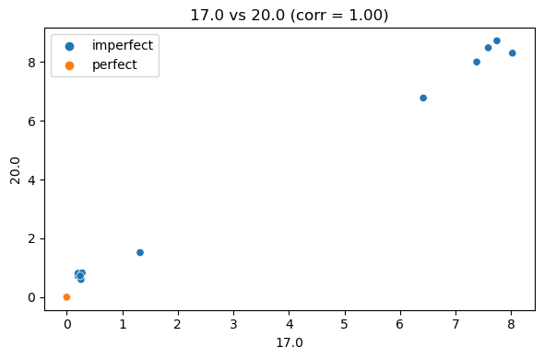

Data Challenges
Several key challenges were identified and addressed during preprocessing:
- Class Imbalance: The "perfect" class was heavily underrepresented. This was addressed by using class_weight={0:1, 1:5} in the Random Forest model to amplify the minority class during training.
- Noisy/Non-numeric Entries: Artifacts such as textual data embedded in numeric columns were removed via coercion and imputation.
- Ambiguous Zero Values: Interpreting zeros as missing values rather than biological signal significantly improved model learning.
- Feature Redundancy: Low-variance and highly correlated features were removed or monitored to prevent overfitting and enhance model generalization.
These steps collectively ensured that the dataset was accurately cleaned, standardized, and made suitable for robust classification modeling.

Model Selection
The classification model selected for this task was the RandomForestClassifier from the scikit-learn library. This choice was motivated by several important characteristics of both the data and the problem:
- Robustness to Noise and Outliers: Given the biological nature of the dataset and the presence of experimental noise, Random Forests are ideal due to their insensitivity to non-linear relationships and noisy features.
- Handling Class Imbalance: The training set was significantly imbalanced, with far fewer samples labeled as "perfect" compared to "imperfect". Random Forests support the use of class_weight, which was set manually as {0:1, 1:5} to upweight the minority class and improve its recall.
- Interpretability: Random Forests provide feature importance scores, which are helpful for understanding which time points contributed most to the model's decisions.
- Overfitting Resistance: Due to their ensemble structure (multiple decision trees with bagging), Random Forests generalize well and are less prone to overfitting than single-tree models.
- Ease of Integration with Preprocessing: The Random Forest algorithm integrates smoothly with imputed, standardized data and does not assume feature independence or normality.
Given the small size of the dataset and the subtle but important differences between "perfect" and "imperfect" classes, Random Forests offered the best trade-off between performance, interpretability, and robustness without requiring extensive parameter tuning or complex architecture design.
Model Training
Two variations of the Random Forest model were trained and evaluated to optimize classification performance, particularly with respect to the underrepresented "perfect" class.
- Initial Model (Train-Test Split):
- The first model was trained using an 80/20 stratified train-test split.
- The RandomForestClassifier was configured with n_estimators=300 and class_weight={0:1, 1:5} to penalize misclassification of the "perfect" class.
- Feature scaling, missing value imputation, and variance thresholding were performed as part of the preprocessing pipeline.
- Instead of using the default probability threshold of 0.50 for binary classification, a lower threshold (e.g., 0.30 and 0.40) was explored. This tuning aimed to increase sensitivity to the minority "perfect" class without introducing excessive false positives.
- Once the optimal threshold was identified (0.40), the model was retrained on the full training dataset using the same preprocessing steps and hyperparameters. This model was then used to generate predictions on the unseen evaluation dataset.
- This model achieved perfect classification performance on the validation split, but was recognized as potentially overfit to that specific partition of the data.
- Enhanced Model (Cross-Validated Training):
- To improve generalizability, a second model was trained using Stratified K-Fold cross-validation (n=3), with the same architecture and threshold tuning applied.
- Each fold preserved the class distribution, and the model was trained and validated three times to assess consistency.
- The threshold of 0.40 was retained from the earlier tuning analysis, which had shown optimal balance between precision and recall.
- Results from the cross-validated model demonstrated slightly lower but more realistic performance, with one misclassification in the "perfect" class, confirming the model’s robustness across data partitions.
Both models used the same preprocessing and hyperparameters, but the cross-validated model provided stronger evidence of generalizability. This enhanced model was selected for deployment and final evaluation on unseen data.

Model Evaluation
Model evaluation was conducted in two phases: an initial train-test split followed by cross-validation to assess generalizability and reduce evaluation bias.
- Initial Train-Test Split Evaluation:
- The dataset was split into 80% training and 20% validation using stratified sampling.
- At a decision threshold of 0.40, the model achieved 100% precision and recall on both "perfect" and "imperfect" classes.
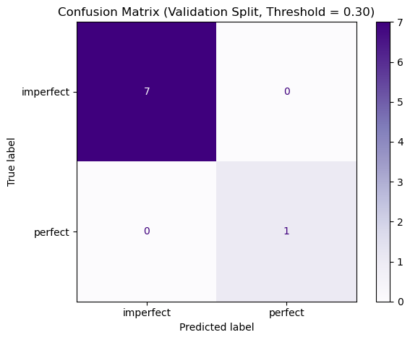
Classification Report (Validation Set, Threshold = 0.30):
precision recall f1-score support

imperfect 1.00 1.00 1.00 7
perfect 1.00 1.00 1.00 1

accuracy 1.00 8
macro avg 1.00 1.00 1.00 8
weighted avg 1.00 1.00 1.00 8

- The ROC and Precision-Recall curves also reflected perfect classification with AUC = 1.00 and Average Precision = 1.00.
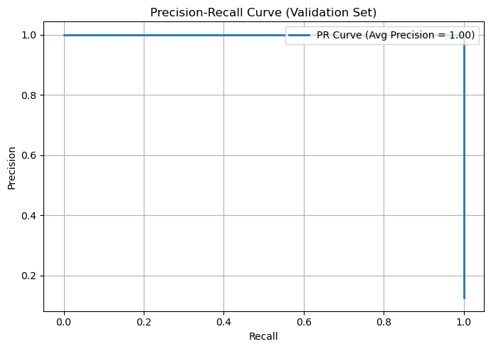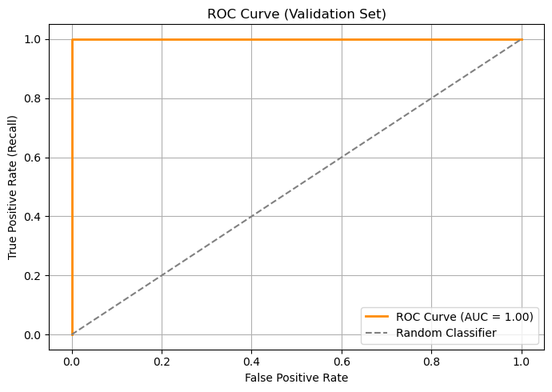

- While promising, these results may be overly optimistic due to the small validation set size and favorable random split.
- Threshold Tuning:
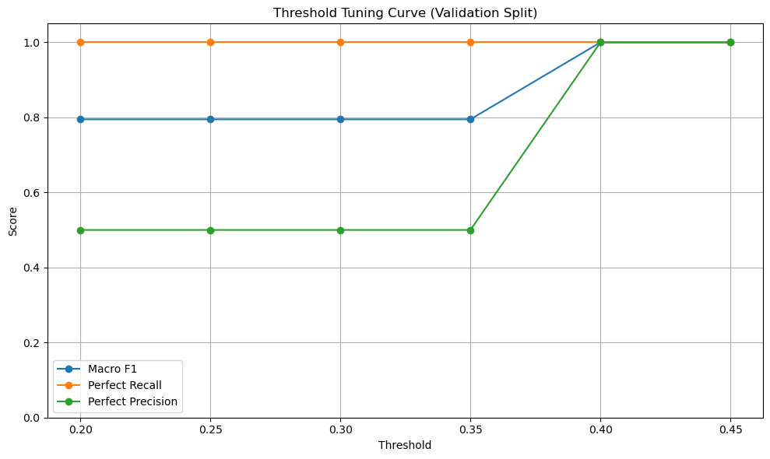
- To optimize classification of the minority "perfect" class, probability threshold tuning was applied.
- A sweep across thresholds from 0.20 to 0.45 showed that a threshold of 0.30 provided the initial ability to identify "perfect" samples.
- Increasing the threshold to 0.40 provided the best trade-off between precision and recall, especially in avoiding false positives.
- This threshold was then used consistently in both the train-test and cross-validation evaluations.
- Stratified K-Fold Cross-Validation (n=3):
- To ensure generalizability and reduce the risk of overfitting to a specific validation set, 3-fold cross-validation was performed.
- The data was evaluated across 3 folds, each maintaining the same class ratio using stratification.
- The aggregated results across all folds were as follows:
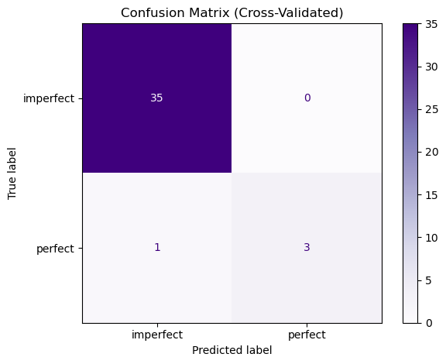

Combined Classification Report (Across All Folds):
precision recall f1-score support

imperfect 0.97 1.00 0.99 35
perfect 1.00 0.75 0.86 4

accuracy 0.97 39
macro avg 0.99 0.88 0.92 39
weighted avg 0.98 0.97 0.97 39

  - Imperfect class: 100% correctly classified (35/35)
  - Perfect class: 3 out of 4 correctly classified (recall = 0.75)
  - Only 1 false negative (perfect misclassified as imperfect)
- The weighted F1-score was 0.97, and the model achieved an overall accuracy of 97% across folds.
- The cross-validated confusion matrix showed strong consistency, with the model making accurate predictions across different folds.
- Final Verdict: Although the train-test split demonstrated perfect classification, the cross-validation results offer a more conservative and realistic estimate of model performance. The model generalizes well and consistently distinguishes between the two classes with minimal error, particularly for the rare "perfect" class. The ROC AUC and PR AUC scores on the validation set confirm that the model is not only accurate, but also well-calibrated in distinguishing positive class probabilities.
- Final Predictions on Evaluation Data:
- The model was retrained on the full dataset and applied to the evaluation dataset.
- Though labels for the evaluation dataset are unavailable, visual inspection of predicted class counts and confidence distributions (probability histograms) indicated confident and balanced predictions.
- These visualizations confirmed that the model was able to assign high confidence to “perfect” predictions when appropriate, reflecting a well-calibrated decision function.
- Evaluation Visualizations (Evaluation Set):
- A set of diagnostic plots were created based on model predictions on the evaluation dataset to support interpretability:
  - Predicted label distribution confirmed that the model returned slightly more "imperfect" predictions, reflecting cautious classification behavior with the tuned threshold.
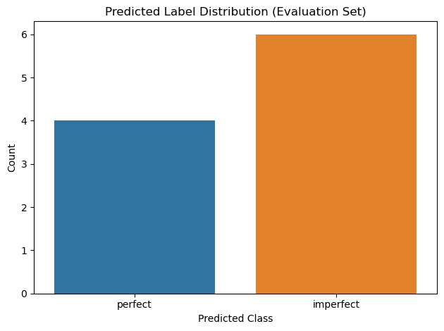
  - Histogram and line plots of the "perfect" class probabilities showed clear separation between predicted classes and visualized how close borderline samples were to the threshold.
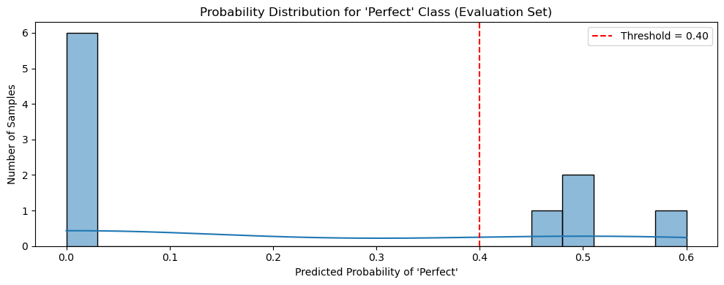
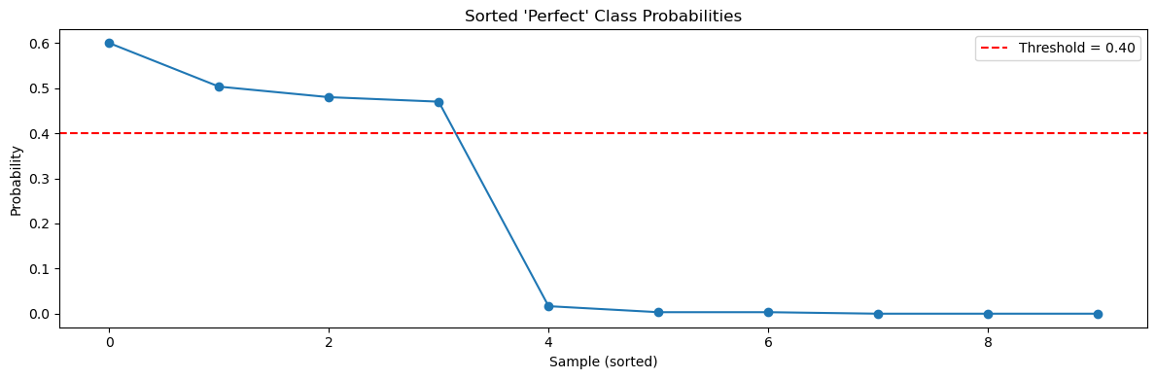
  - Feature importance bar chart revealed the top 10 most influential timepoint features driving the model’s decisions, enabling insights into signal contribution.
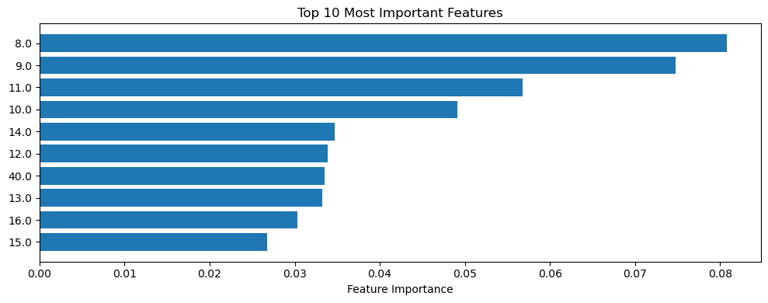
- These visuals affirmed that the model was confidently classifying a small group of high-probability "perfect" instances and that decision boundaries were well-aligned with learned feature contributions.

- Prediction Script Execution:
- To support model reuse and reproducibility, a standalone predict.py script was implemented.
- This script loads the saved model and preprocessing pipeline, processes a new evaluation CSV file, applies the 0.40 threshold, and prints class predictions with probability scores.
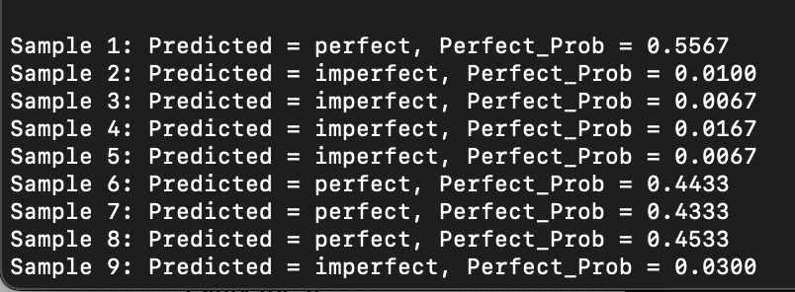
- It accepts command-line input for both the file path and threshold (optional override), and was successfully executed using:
python prediction.py /path/to/evaluation_data_external.csv --threshold 0.40
- This step confirms that the model can be deployed and used efficiently for inference outside of a notebook environment.
The evaluation results indicate that the trained Random Forest model is highly accurate and robust, with strong generalization confirmed through cross-validation. The inclusion of probability threshold tuning, command-line prediction support, and visual performance diagnostics further supports confidence in model performance.

Data Challenges
Throughout the analysis and modeling process, several challenges were encountered and systematically addressed:
- Extremely Limited Samples for the 'Perfect' Class:
- The dataset was heavily skewed toward the "imperfect" class, with the "perfect" class representing fewer than 10% of the samples.
- To address this, the model used manual class weighting (class_weight={0:1, 1:5}) to penalize errors on the minority class more heavily.
- Unreliable Zero Values:
- Initial inspection revealed that many zero entries did not reflect meaningful biological signal but instead likely indicated dropout or missing measurements.
- Zeros were replaced with NaN and subsequently imputed, which improved classification performance for the "perfect" class.
- Presence of Non-numeric or Textual Data:
- Erroneous entries such as 'good' and 'early' were discovered in some time series columns.
- These were coerced to NaN and handled via imputation to prevent model errors and preserve structure.
- Highly Correlated and Redundant Features:
- Adjacent time points exhibited strong autocorrelation.
- The model used VarianceThreshold and visual inspection of correlation matrices to identify and minimize the effect of redundant features.
- Choosing the Right Threshold:
- Since model sensitivity to the minority class was critical, default thresholds produced poor recall for "perfect".
- Threshold tuning revealed that 0.40 offered the best precision-recall trade-off.
These challenges impacted the model’s learning capacity and interpretability. By methodically addressing each one, the modeling process was strengthened and the resulting classifier demonstrated meaningful discrimination between imperfect and perfect samples.

